October 13, 2015

Tushar Tiwari

LAB 2

EE 450 Session 3

Q1. It is 163.53.78.58

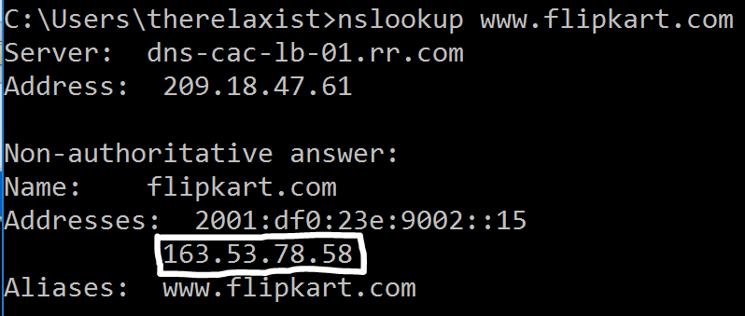

Q2. I chose oxford university. The authoritative DNS servers are encircled.

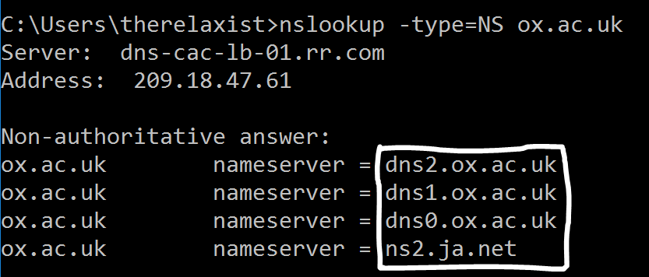

Q3. 98.136.189.41. The DNS server I chose is ns2.ja.net but that refused my query. So I chose Google’s DNS Server (8.8.8.8)

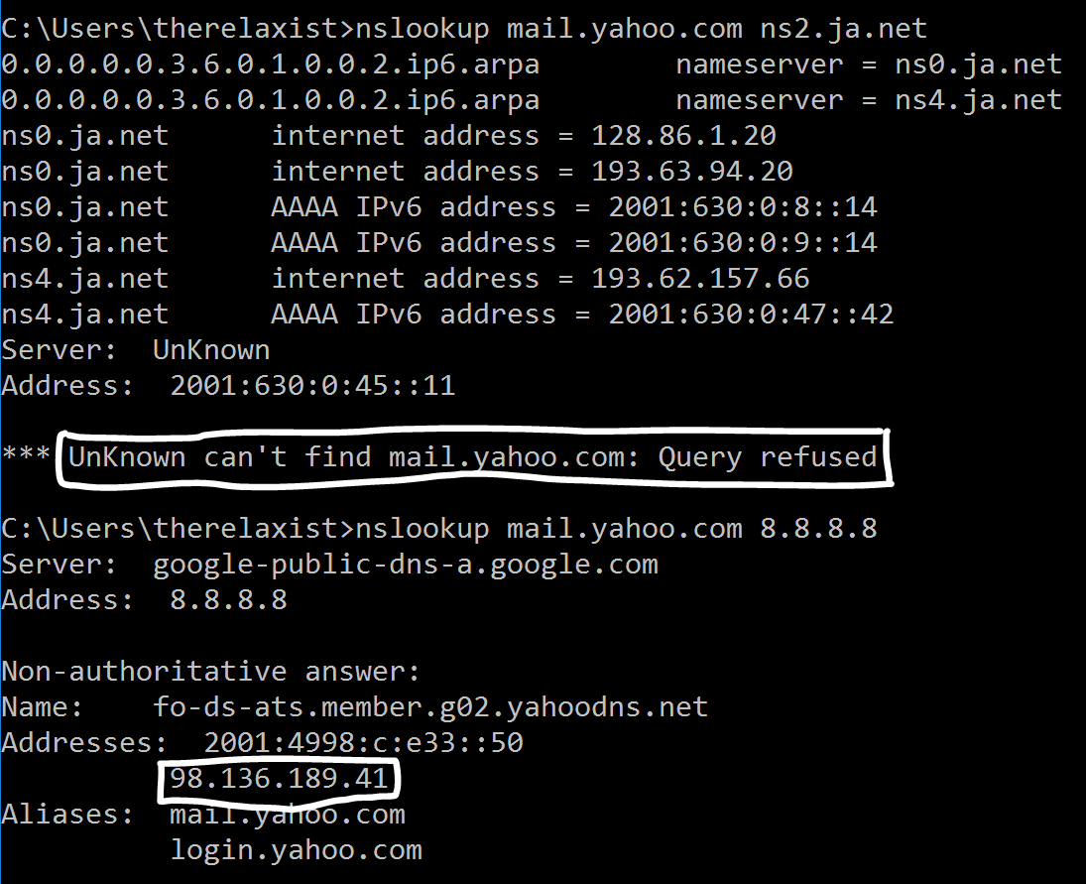

Q4. They are sent over UDP.

Q5. Destination Port is 53. Source Port is also 53.

Q6. The IP address is 209.18.47.62

Q7. It is of type A. Contains no answers.

Q8. 1 answer is provided. It contains the hostname, type, class, TTL, data length and the ipv4 address itself.

Q9. Yes, it is the ip address provided in the answer.

Q10. No.

The DNS Query

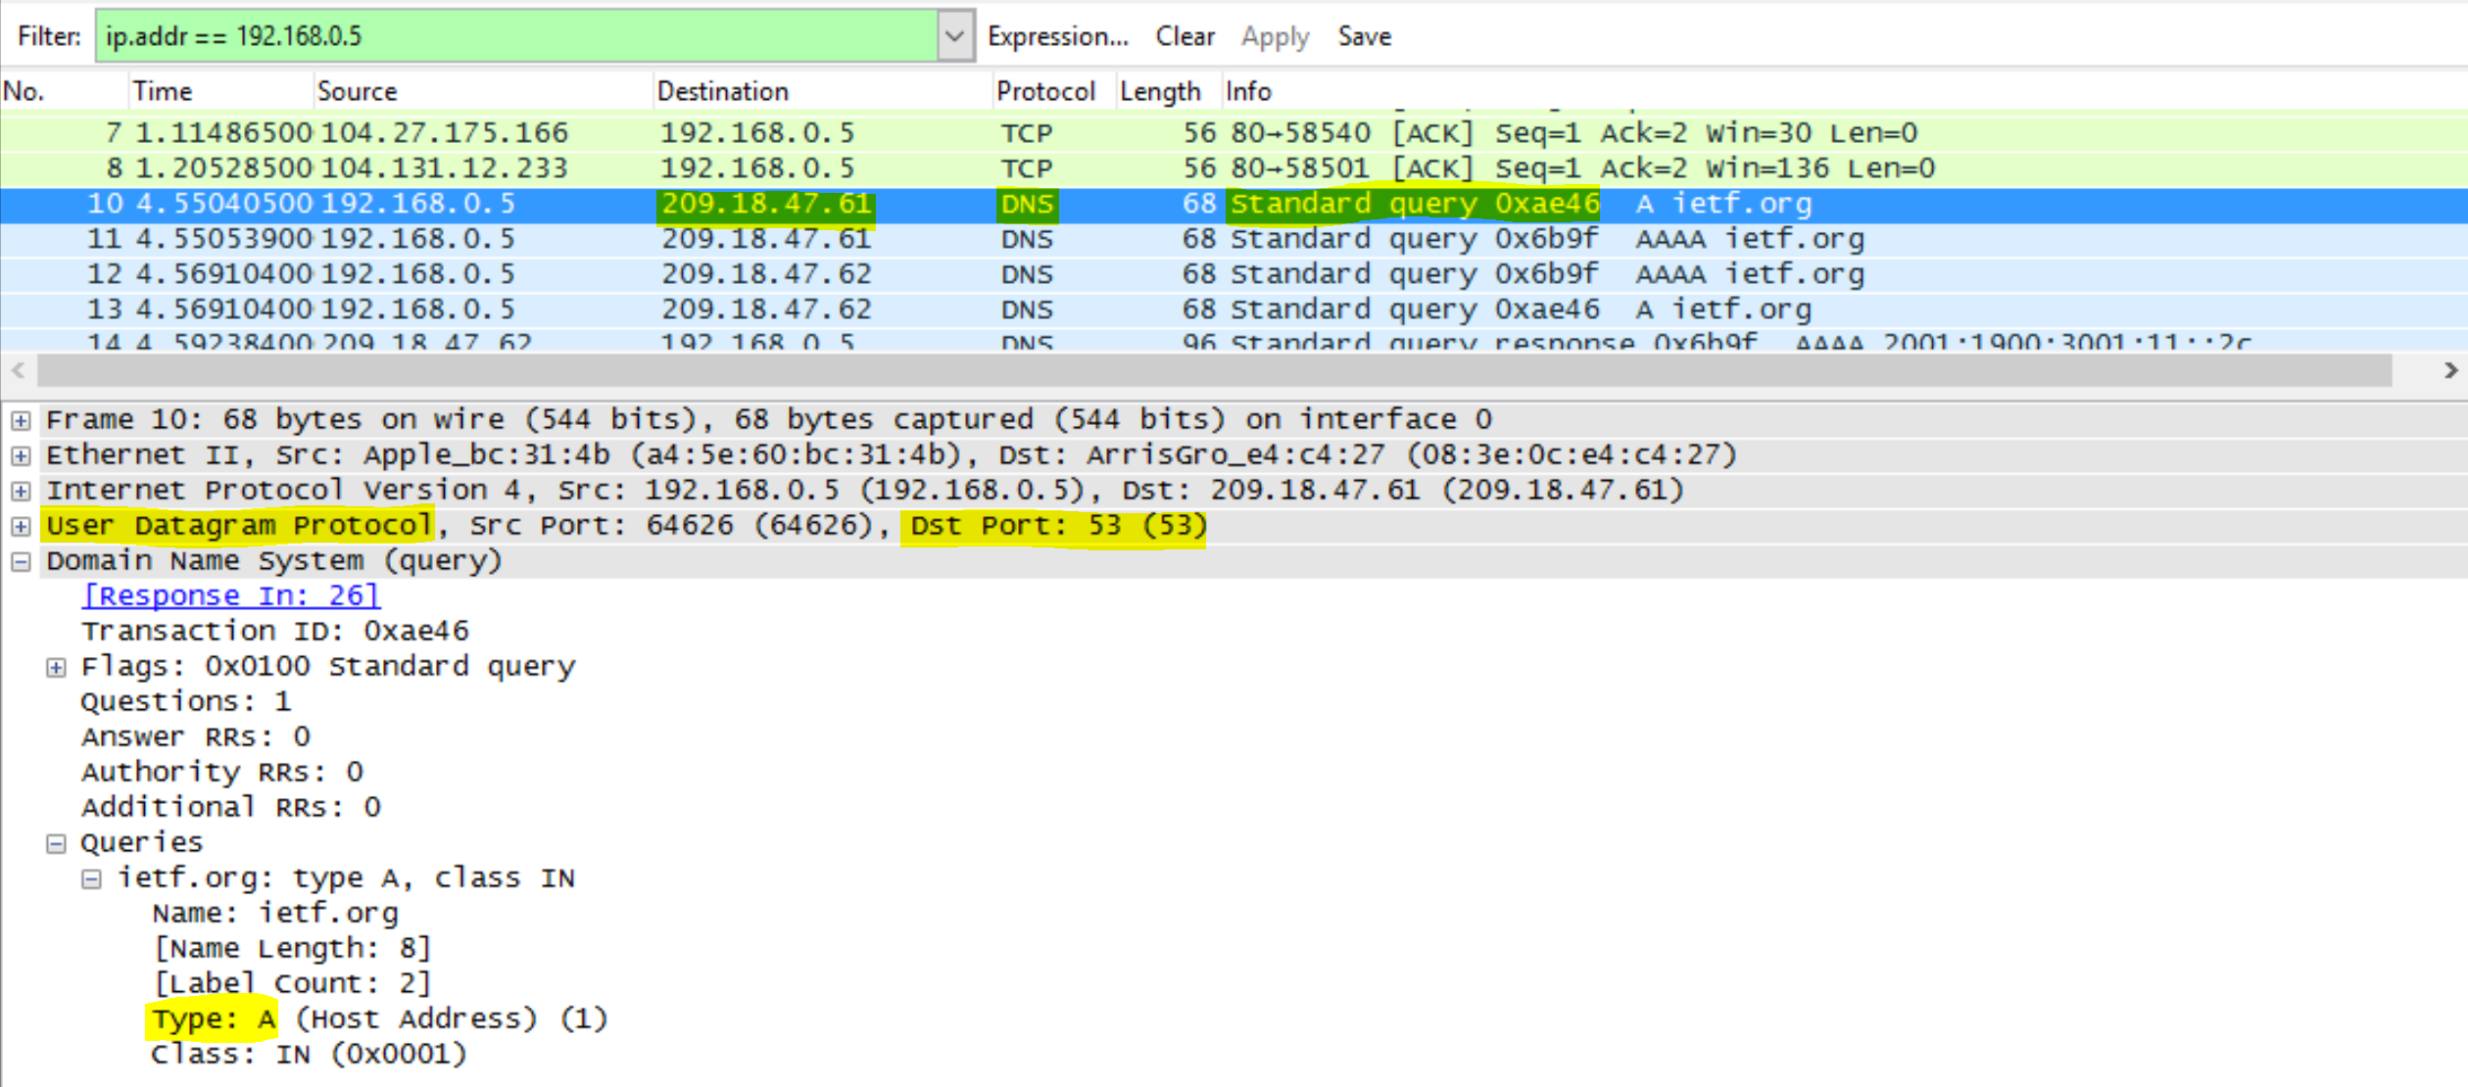

The DNS Response

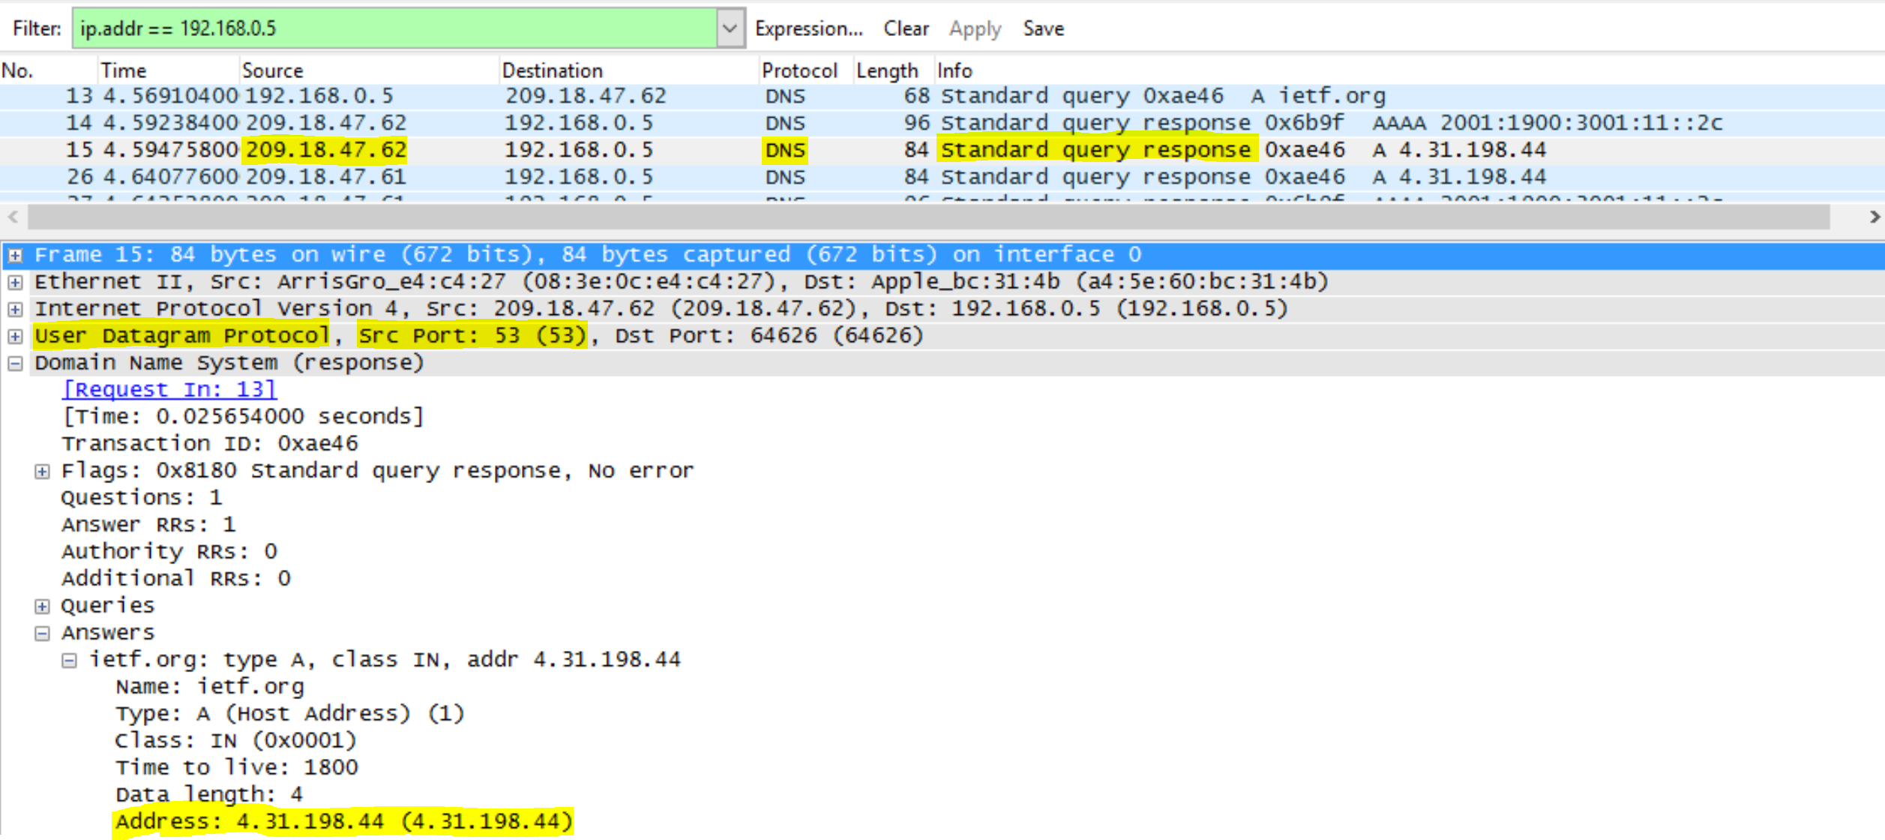

ipconfig /all - This shows the default DNS server provided by DHCP.

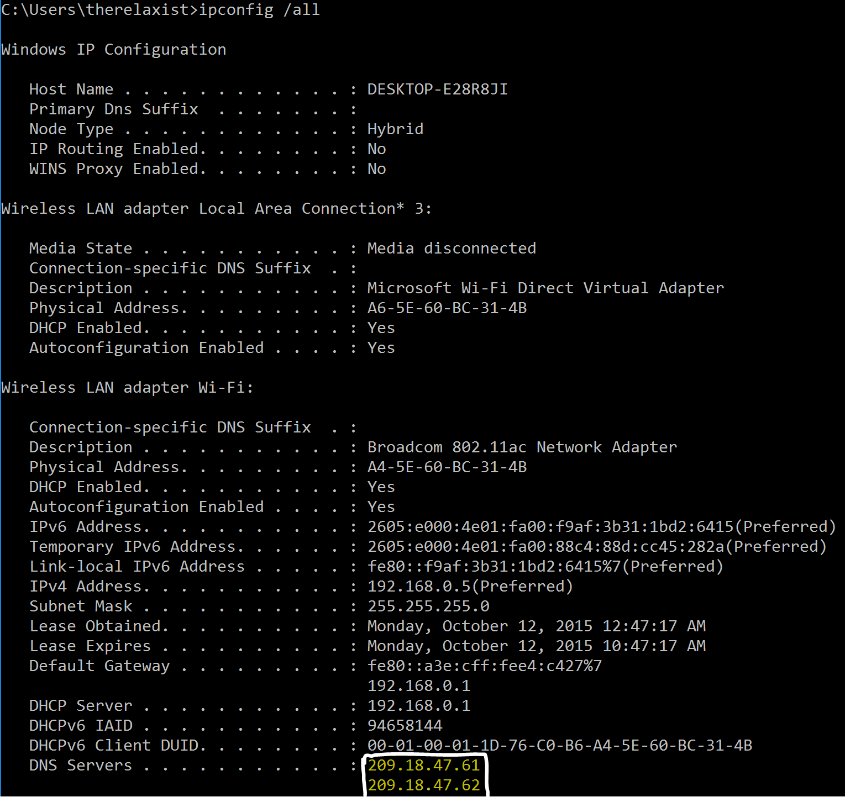

Q9. Yes, it contains the ip-address returned in the answers section.

Q10. No

Q11. Destination Port: 53. Source port: 53.

Q12. 209.18.47.61. Yes. (See previous ipconfig /all for default DNS)

Q13. Type A. Contains no answers.

Q14. Only 1 answer is provided. It contains the hostname, type, class, ttl, data length and address of mit.edu.

DNS Query

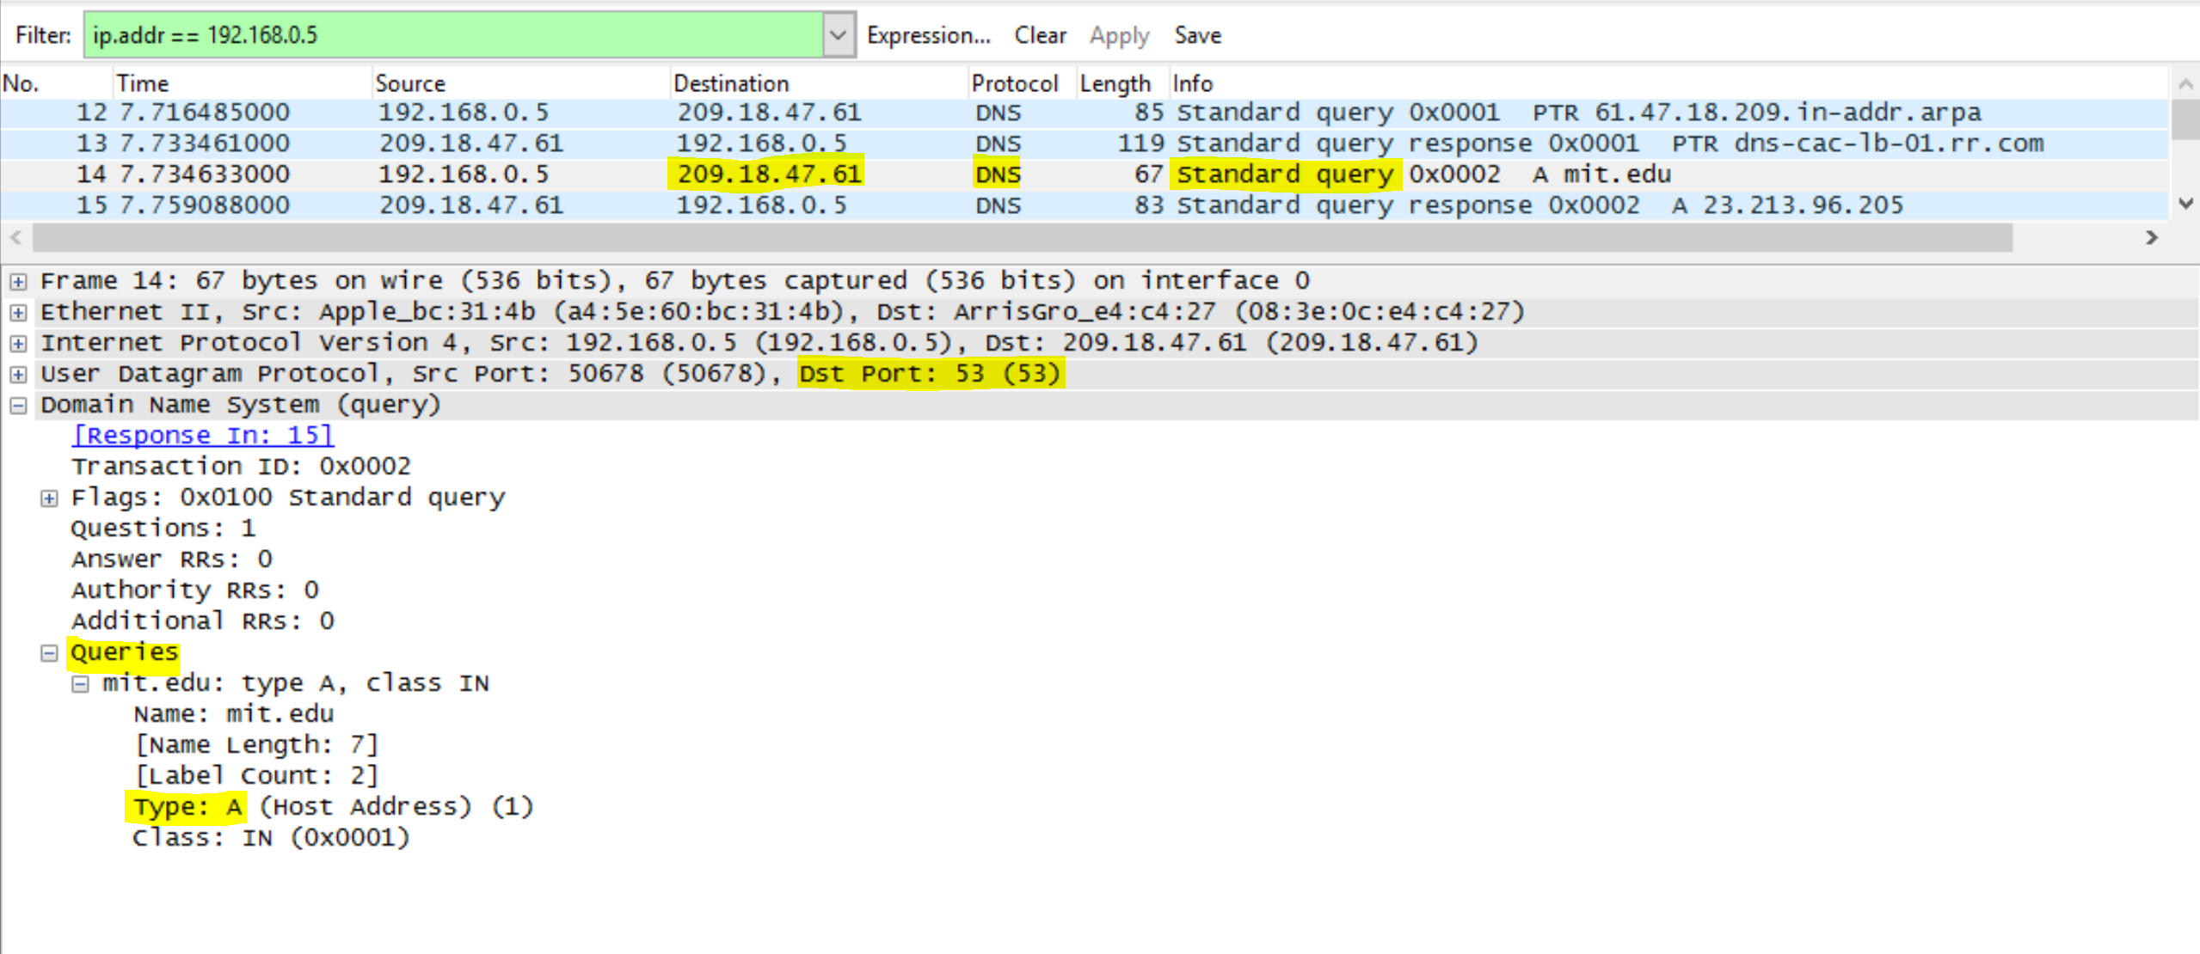

DNS Response

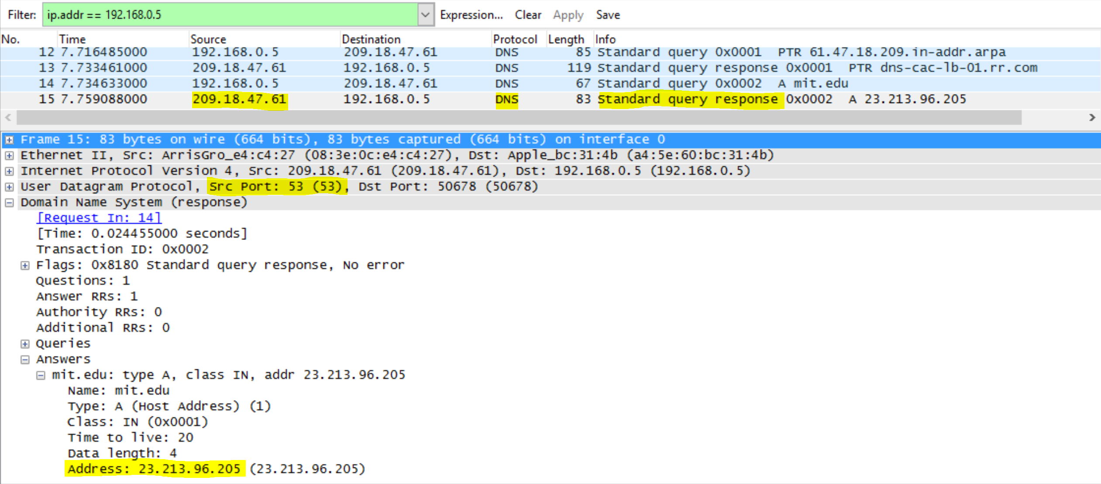

Q16. 209.18.47.61. Yes. (See previous ipconfig /all for default DNS)

Q17. Type NS. Contains no answers.

Q19. 8 answers are provided. The name servers are asia1.akam.net, asia2.akam.net, usw2.akam.net, ns1-37.akam.net, use2.akam.net, use5.akam.net, ns1-173.akam.net, eur5.akam.net. No it does not contain the IP addresses.

DNS Query

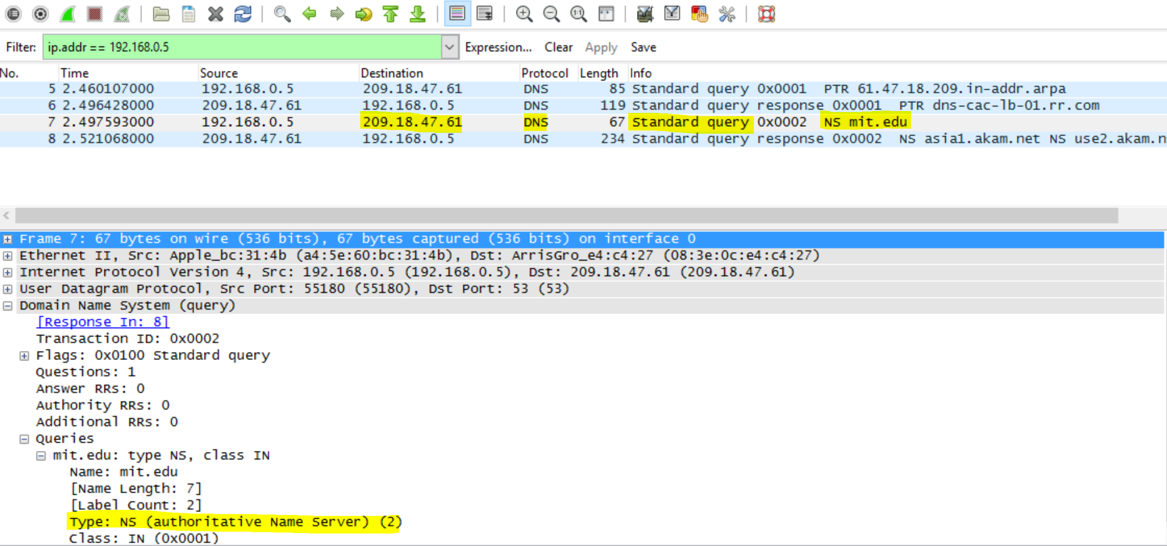

DNS Response

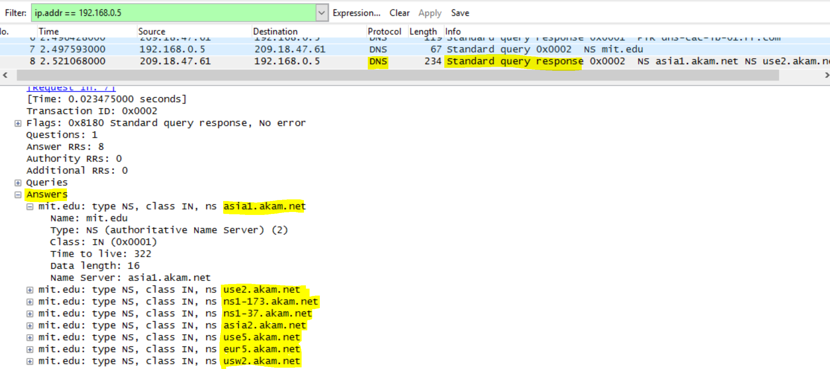

Command is **nslookup flipkart.com google-public-dns-a.google.com**. Because neither of the hostnames given in the question work.

Q16. 8.8.8.8. No. (See previous ipconfig /all for default DNS). It corresponds to google-public-dns-a.google.com.

Q17. Type A. Contains no answers.

Q19. Only 1 answer is provided. It contains the hostname, type, class, ttl, data length and ip address of flipkart.com.

DNS Query

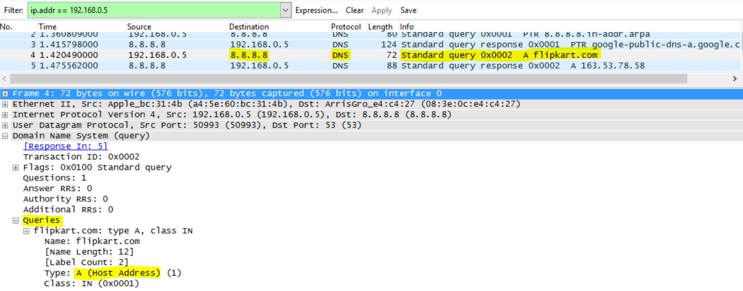

DNS Response

